**Do you know what this three novels have in common?**

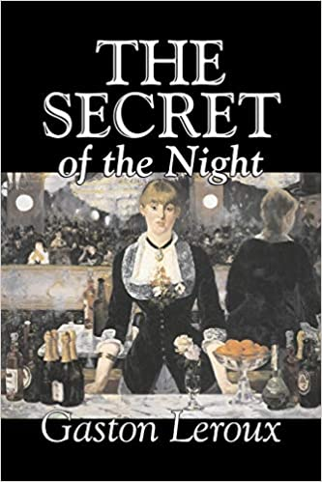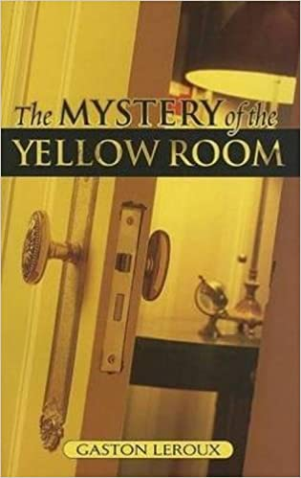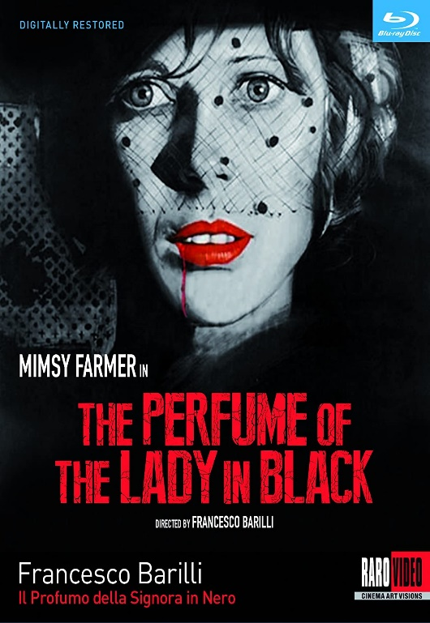

The three novels have the same main character, who is the detective Joseph Rouletabille, a very famous and known character created by Gaston Leroux.